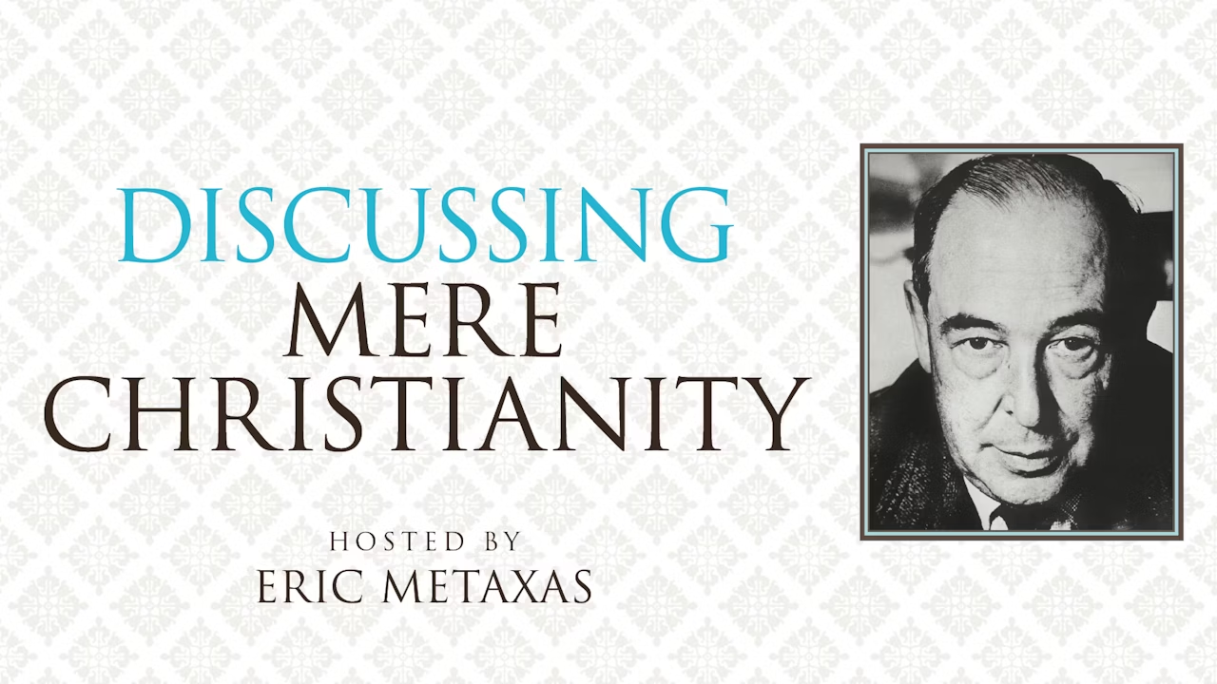

In this 8-session video group study, you will discover why Mere Christianity by C.S. Lewis is one of the most read and beloved Christian books of all time. But seventy years later from when it was first delivered on the BBC radio in the middle of WWII as a message of Hope, what relevance does it have to our world today? Host Eric Metaxas and a variety of Christian leaders (Philip Yancey, Lewis’ stepson Douglas Gresham, and professors from Oxford, Wheaton College, Azusa Pacific University, Asbury University, and Aquinas College) help us understand the timeless message of C.S. Lewis in fresh ways for a new generation. This Bible study will meet on Tuesdays at 7:30pm in the youth hall
at St. John’s UMC. The study guide is $11.00.

Contact Pastor Chuck Cole with any questions at chuckcole@vaumc.org.

1716 N. Augusta St, Staunton, VA 24401•www.stjohnsstaunton.com•
(540) 886-1500•stjohnsumc@verizon.net

