

1st- Alma Driver
2nd- Don Davis
3rd- Nancy Fitzgerald
10th- Al Hammer
19th- Mimi Insco
22nd- John Herndon
28th- Hal Ralston, Hanna Crider
29th- Lee Hodge




1st- Tucker Kirby
7th- BJ Kirkpatrick
17th- Eric Fitzgerald
19th- Mitch Carr

22nd- Lily Mae Cole
30th- Page Harmon, Lisa Kirby


8
ST. JOHN’S UMC EPISTLE

MAY/JUNE 2026
Pastor: Rev. Chuck Cole
Table of Contents~
Page 2….From the Pastor
Page 3….From the Pastor
Page 4….Church News
Page 5….Preschool News
Page 6….Reflection
Page 7….History
Page 8….Birthdays
Insert…..Calendars

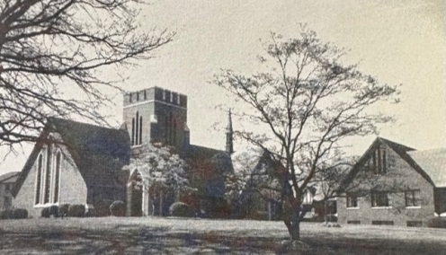

1716 N. Augusta St.
Staunton, VA 24401
(540) 886-1500; stjohnsumc@verizon.net
www.stjohnsstaunton.com; facebook.com/stjohnsstaunton


Dear Brothers and Sisters of St. John’s,

Christ is Risen!

As you read this, we are continuing in the Easter Season. Throughout Easter Season we are very purposefully focusing on the Good News that “Christ has Died, Christ is Risen, Christ will Come Again”.

On May 24 we will celebrate the Day of Pentecost. When the Day of Pentecost comes, we rejoice in the day when the Good News of Resurrection Hope was propelled to all the nations as we the Body Of Christ began to make Disciples for him empowered by the Holy Spirit.

Our basic calling as the church is to seek to place ourselves in the middle of his Grace such that we are made each day more and more into His disciples so that we are making disciples for Him here in Staunton and to the ends of the earth.

In this regard please be in prayer for the ministries of the church we and others would become Disciples or be moved forward in Discipleship. Specifically pray for upcoming disciple making opportunities that we support and through our members participate in specifically Camp Overlooks Summer Camp Program and Rainforest VBS that we are working on with Cherryvale and Christ UMC at Christ.

Over the years there have been and are now ministries at St. Johns born of a prompting on the heart of a lay person be they an adult or youth. If you feel such a leading on your heart, I would be excited to hear about it and see what the Lord might do through us in response.

May the peace of Christ fill your heart as you seek to grow as his disciple each and every day.

In Christ,
Rev. Chuck Cole

Renewal Leave

The Discipline of the United Methodist church allows a period of Renewal Leave for Pastors after 6 years of full-time ministry. Spiritual Renewal leave is intended through retreat, reading, reflection and rest to strengthen the pastor, so they are more fully able to lead upon their return. After 17 years of full-time ministry with the approval of the SPPRC, the Church Council and the District Superintendent after I will be taking an 8 week renewal leave from July 27-September 21st. I believe I am in a place where my ministry, and so St. John’s, and the church as a whole, would benefit from a period of purposeful renewal for me.

During my renewal leave Preaching and Pastoral Care have been arranged, a schedule of preachers and those offering pastoral care can be found below. If desired and I am in-town I will attend to pastoral emergencies and funerals if requested. I am confident that my colleagues will be able to offer pastoral care with love and skill in any situation that might arise. Administrative issues will be dealt with as much ahead of time as possible, but the lay leadership of the church is well equipped and fully capable of handling any issue during my absence. In case of an emergency the District Superintendent will be available as always.

2
BITS & PIECES~ MARCH-APRIL 2026
I was trying to find some info on the clergy during the American Revolution. I found this great article entitled “Unsung Clergy of the American Revolution”. “The role of the clergy during the American Revolution has been grossly underreported by most historians. The influence of Christian pastors was perhaps the most fundamental force toward American independence.” In fact, Noah Webster, stated in a letter in 1836, “the learned clergy…had great influence on the founding the first genuine republican governments ever formed.” There was also a book published in 1864 by Joel Tyler Headley called “The Chaplains and Clergy of the Revolution”, in which he makes no attempt to be exhaustive concerning minister who contributed so greatly to American independence.  There are at least 23 ministers included in this article. I can’t list all of them with their bios, but I thought for the next few articles, I would highlight some of them.  Dr. David Ely of Huntington, Connecticut, though surrounded by Tories, preached rebellion so warmly and effectively that when the  rebellion was put down; the Tories would hang him on an oak near his own church.  Jonah Stearns of New Hampshire not only preached rebellion but gave most of his worldly wealth to sustain it. It’s reported he said to his boys assembled to hear his report: If the cause succeeds, it will be a great blessing to the country; but if it should fail, your old father’s head will soon be a button for a halter!”.  Dr. David Cauldwell of Pennsylvania had his house plundered, his library and furniture burned while he was hunted over the country because of his devotion to the cause of liberty. | There was also another David  Caldwell in North Carolina, a Presbyterian minister who was in the backwoods NC. He also became a self-taught practicing physician, which became useful during the war. His sermons inspired wary Scotch-Irish to take up arms and fight against the British oppression. At one time, he hid in a swamp while Cornwallis offered a £200 bounty for his capture.  William Graham, also of Pennsylvania, saw the backwardness in the young men of his parish to enlist in a company of volunteers, so he stepped up, had his own name enrolled, thus shaming them into patriotism.  John Steele of Cumberland PA was another Presbyterian minister who led the advanced company of nine hundred men to their march to the seat of war and often preached with his gun standing by his side.  And finally, Francis Cummings, another patriotic Presbyterian minister, fought in several battles and was present at all the Mecklenburg meetings. Although nearly 80 years old, when South Carolina threatened nullification (in Nov 1832) a fellow clergyman who declared in a moment of excitement, that he was ready to draw his sword against the American government. Mr. Cummings declared “If you dare do so, I will draw my sword again and cut you down!”  I found some historical dates you may or may not be aware of.  May  14 May – Ascension of Jesus  24 May – Pentecost Sunday  31 May – Trinity Sunday | June  4 June – Corpus Christi –  Commemorates the presence of the Body and Blood of Christ in the  Eucharist  12 June – Feast of the Sacred Heart –  Honoring Christ’s boundless love  and mercy for humanity.  24 June – Nativity of St. John the  Baptist  29 June – Saints Peter and Paul –  Honors the martyrdom of the apostles  WHAT WAS HAPPENING 25  YEARS AGO?  6 May – Rev. C Randall Harlow was guest preacher  27 May – there were new bumper stickers available that read “Open Hearts, Minds and Doors”. Also, a drive was held to raise money for the new sign out front. Cost was $3,000.00  3 June – the rosebud on the altar was for Allan Michael Hammer, son of Mike and Gwen Hammer, born 10 May  50 YEARS AGO  8 May Carole Stone and Howard Cassidy Jr were married.  15 May – Mildred Waybright and James Beverage were married at St. John’s  13 June – flowers on the altar were honoring Nettie Baker – a bride of 50 years (also Frank and Nettie’s  anniversary)  - Sooner or later, we all quote our mothers.  - The best dads see you at your worst but focus on the best in you.  Cindy Phillips
7

The Caterpillar and its transformation into a Butterfly is a traditional Easter them that helps us grasp the resurrection of the Christian in both the present and finally on the day of Christ’s Return. This poem was written in response to a reflection on that reality during the Easter Service.

Satisfied to Be a Caterpillar~ 4/5/26

Inching into the springing, forth
come leaves and blooms, I saw
and partook as my satisfaction.

In the change of season, at each
planting born, a seed dies, I saw
myself as the caterpillar, unseen.

Feeding my appetite and need
to move through leaf and bloom, I saw
my growth only in scale to the space I took.

Up to the point I could eat, no more
could this limiting body hold inside, I saw
a place to alight myself to rest and wrap myself.

In accepting, that which I did not know
would bring about complete change, I did not see
take place from within, a transformation.

My entire being, springing forth
a bloom out to a greater space, I now see
that I can take flight, to cast off into.

A new life, delivered to beauty, unfurled
robes of glorious sight, I now see
the Son that gives life to all I need.

~Jason Fullerton

6
During my renewal leave I will forgo my take home pay of roughly $5200. Although typically pastors are paid during renewal leave, I am forgoing my take home as a way to assist the church in compensating guest preachers (other than the DS) but also as a way to indicate how valuable I believe this leave will be.

While the details of the leave are being developed the leave will consist of travel facilitating renewal, Silent retreat, reading and reflection on spiritual works that will enrich me spiritually and benefit my ministry, adoption of new habits of self-care, times of learning through time spent with colleagues in a variety of ministry settings and discerning the possible pursuit of further education as I continue in ministry.

I will happily answer any questions you may have. Please feel free to talk to me in person, to call/text me at 804-387-2029 and email at Chuckcole@vaumc.org.

In Christ,
Chuck Cole
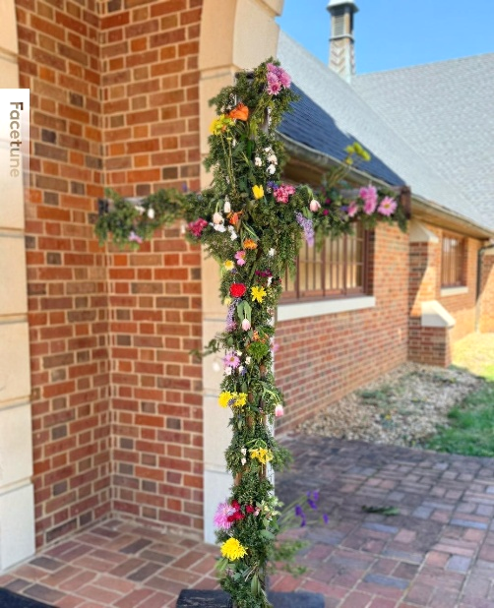
Pastoral Care Schedule~

Brett Isernhagen - July 27- Sunday August 9th
Tizzy Walker - August 10th-23rd
Jonathan Greer - August 24th - 30th
Jim Harris - August 31- September 14th
Jonathan Greer - September 15-21

Preaching ~

8/2 - David Rash (Holy Communion)
8/9 - David Rash
8/16 - Alan Combs (Holy Communion)
8/23 - Bill Bearden
8/30 - Bill Bearden
9/6 - Jim Harris (Holy Communion)
9/13 - Jim Harris
9/20- Jim Harris

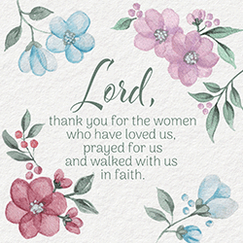
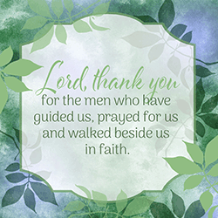

3
Church News News



The Trustees are continuing with making improvements to our Church building. The painting project was recently completed with new paint in both Social halls, hallways, Narthex and parlor as well as repairs to water damage in the Sanctuary. The next phase, beginning Monday, April 20, is replacement windows for both social halls & kitchen as well as the pre-school and office. Following that in early May, the floors in both social halls, kitchen, and hallway from the social hall to the sanctuary and office will be resurfaced with vinyl tile. We will also be doing some exterior painting in the coming months.

We hope you have an opportunity to keep up with and see all the results of these projects!

Kim Harris, Trustees Chair



Noisy Can Offering

The Noisy Can Offering is taken up by the youth of the church each first Sunday of the month. The offering supports a mission of their choice.

At present the Noisy Can Offering Supports the International Justice Mission (IJM) which is a global Christian non-governmental organization (NGO) dedicated to protecting people in poverty from violence, slavery, and sexual exploitation. Founded in 1997, IJM partners with local authorities to rescue victims, bring criminals to justice, and strengthen justice systems.
Please prayerfully consider how you might support this outreach. If you are in worship on the first Sunday of the month, please bring change (makes a fun sound when it clinks in the can), or cash to put in the can as the kids collect it. You may also give to the noisy can offering online at the website or put an offering in the offering plate another Sunday please just note in either case that it is for the Noisy Can Offering.

4


The month of March was full of joy and meaningful moments at St. John’s Preschool as we celebrate the beauty of spring and the blessings of new life. Our students spent time learning about Holy Week and took part in a special Psalm Parade led by Pastor Chuck. It was a wonderful way for the children to experience the message of Easter in a joyful and memorable way.
We also enjoyed a special field trip to The Legacy of North Augusta. Our students loved visiting with the residents and sharing smiles and songs. Mrs. Laney practiced diligently with students and they performed several songs. It is always a blessing to spend time there and we truly feel like part of the community when we visit.
As the school year begins to end, we are finishing our final lessons and preparing for our End of the Year Program on Wednesday, May 13th at 6:00 p.m. Following the performance, families are invited to gather in the Social Hall for a time of fellowship with cookies and milk. If you would like to contribute, donations are greatly appreciated. Please contact Alissa Jones at stjohnspreschool1@verizon.net.
Registration for the upcoming school year is now open. We are currently enrolling students in our Two- and Three-Year-Old and Four Year Old classes. If you know a family looking for a nurturing environment where children grow in faith and learn about God’s love, we would be grateful if you shared our preschool with them.
We are so thankful for our St. John’s Church sponsor and the continued support that makes all of these experiences possible for our students.

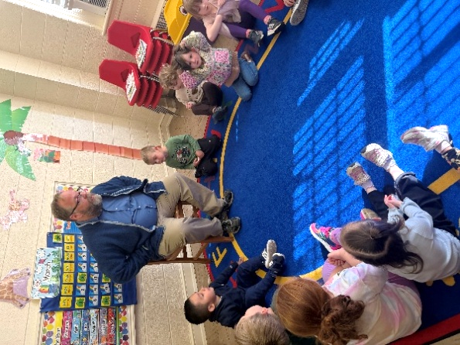
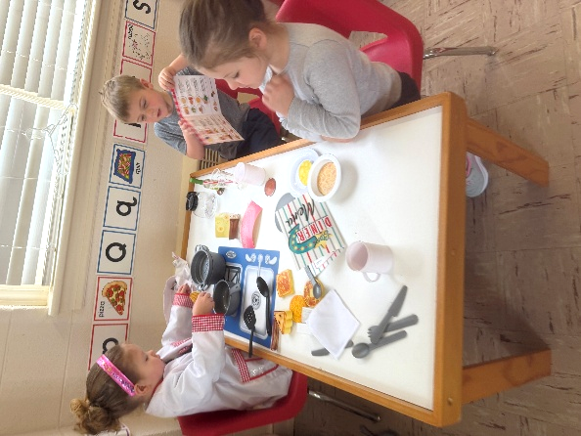
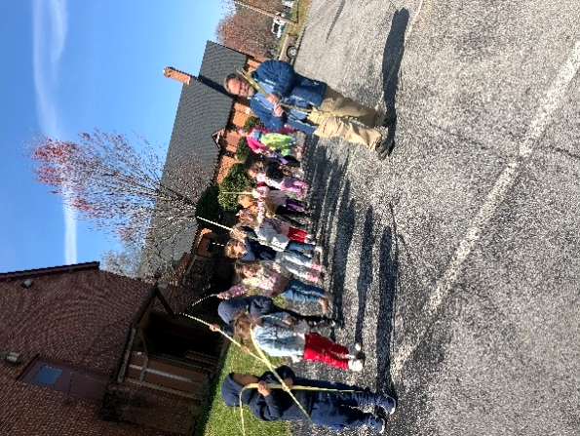

Have a wonderful summer!
St. John’s Preschool Staff

5

