

1st- Molly Langston
4th- Pastor Cole
6th- Anne Frank
30th- Joyce Herndon




3rd- Maria Dzuba
5th- Albert Deavers, III, Mindy Hughes
6th- Mike Miller
9th- Willow Hughes
13th- Dulaney Zullig
17th- Sheila Pyle
18th- Erin Wright, Mandy Crider

22nd- Vicky Phillips
25th- Donna Elkins
26th- Ann Lewis

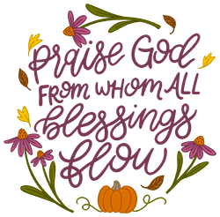

8
ST. JOHN’S UMC EPISTLE

NOVEMBER/DECEMBER 2025
Pastor: Rev. Chuck Cole
Table of Contents~
Page 2….From the Pastor
Page 3….Preschool News
Page 4….Church News
Page 5….Church News
Page 6….OCC Information
Page 7….History
Page 8….Birthdays
Insert…..Calendars

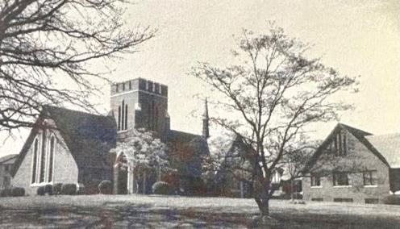

1716 N. Augusta St.
Staunton, VA 24401
(540) 886-1500; stjohnsumc@verizon.net
www.stjohnsstaunton.com; facebook.com/stjohnsstaunton



Brothers and Sisters of St. John’s,

The North Georgia Conference of the United Methodist church one year offered the following guidance for Thanksgiving and the attached prayer calendar. I offer these thoughts and the calendar to you in the hope that we are all able to live each day with eyes opened to the Goodness of the Lord toward us and so live lives of true thanksgiving.

The Bible teaches several truths about offering praise and thanksgiving to God: The Lord is worthy of praise (Ps. 96:4). Everything that has breath should praise the Lord (Ps. 150:6). And God’s name should be praised continually (Heb. 13:15) to the ends of the earth (Ps. 48:10).

Here are five ways to begin celebrating God’s greatness today.

1. Praise God’s character: holy (1 Pet. 1:16), compassionate, gracious, slow to anger, loving, faithful (Ex. 34:6), merciful, forgiving (Dan. 9:9), mighty, all-knowing (Ps. 147:5), unchanging, (Heb. 1:12), trustworthy (2 Sam. 7:28), and eternal (Gen. 21:33).

2. Meditate on God’s names: Almighty (Rev. 1:8), I Am (Jn. 8:58), Bread of Life (Jn. 6:35), Wonderful Counselor, Prince of Peace (Isa. 9:6), Good Shepherd (Jn. 10:11), Immanuel (Isa. 7:14), King of Kings, Lord of Lords (1 Tim. 6:15), Messiah (Jn. 1:41), and Redeemer (Job 19:25).

3. Give thanks for God’s promises: eternal life (Jn. 3:16), forgive ness of sins (Matt. 26:28), peace (Jn. 14:27), refuge (Ps. 5:11), rest (Matt. 11:28), strength (2 Sam. 22:33), courage (Matt. 14:27), comfort (Ps. 23), and enduring love (1 Chron. 16:34).

4. Offer gratitude for God’s creations: heavens, earth, day, night, sky, land, seas, vegetation, living creatures, men, women, and children (Gen. 1-4).

5. Praise God for blessings received: Jesus (Lk. 1:26-38), the Lord’s presence (Matt. 28:20), the Holy Spirit (Jn. 14:26), the Bible (2 Tim. 3:16), prayer (Matt. 6:9), spiritual gifts (Rom. 12:6 8), family and friends (Luke 1:58), pastors (Eph. 3:8), churches (Acts 16:15), faith, hope, love (1 Cor. 13:13), health (1 Sam. 25:6), and work (Jn. 5:17).

Please consider placing the included calendar of daily prayers of Thanksgiving on your refrigerator or another place where you may be reminded to pray them.

In Christ,
Pastor Chuck

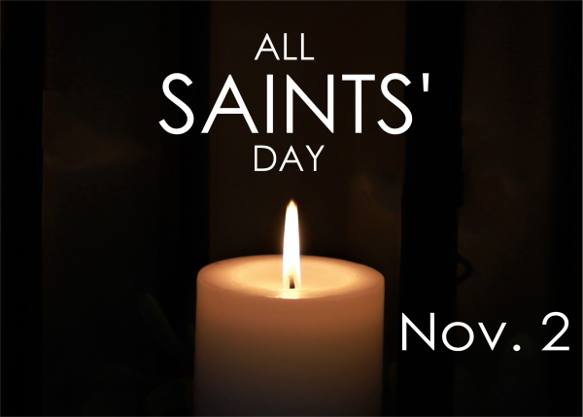
All Saints Day Potluck~

Sunday, November 2nd, an All Saints Day Potluck Feast will follow the Worship Service. The church will provide the meat and drink. Please bring a side dish and/or dessert to share as we celebrate together. We will also be dedicating the cross by the sign as part of the celebration.

2
DID YOU KNOW???? - November – December 2025
For years, we were taught that the first Thanksgiving was held in Plymouth, Mass. In 1691. That’s not exactly true.  A year and 17 days before the Pilgrims set foot in America, 35 settlers, a crew and other crew members sailed to Virginia to settle 8,000 acres along the James River.  After a rough two and a half months at sea, they entered the Chesapeake Bay on 28 Nov 1619. It took them another week to navigate the stormy bay, but they arrived at Berkeley Hundred, later called Berkley Plantation on 4 Dec. They disembarked and prayed. Historians think there was nothing but old ship rations to eat, so they concocted a meal of oysters and ham out of necessity rather than celebration.  At the request of written orders by Capt. Woodlief it was declared that arrival must “be yearly and perpetually kept hold as a day of Thanksgiving to Almighty God”. And they did for 2 years.  On 22 Mar., 1622, the Powhatan, attacked Berkeley and other settlements killing 347. Soon after Berkeley Hundred was abandoned.  For 3 centuries, Virginia’s first Thanksgiving was lost to history. That was until Graham Woodlief, a direct descendant of Capt. Woodlief, stated that he thinks the major reason that Plymouth and not Berkeley, was universally thought to be the site of the first Thanksgiving, was due to better PR. He also said the emphasis on prayer, instead of Plymouth’s festive harvest meal also made Virginia’s Thanksgiving less appealing although more accurate.  Although locals are convinced about Berkeley’s place among Thanksgiving lore, the rest of the country was a harder sell.  In the 1960’s, Senator John J Wicker Jr., pleased Virginia’s case to the Mass. Governor, John A. Volpe. He actually went on the Johnny Carson show dressed in full 17th century garb. When President Kennedy gave his 1962 Thanksgiving | Proclamation and said that Plymouth was the first site of the first Thanksgiving, it was Wicker who chastised the White House for ignoring Virginia.  Much to his surprise, he received a reply from Arthur Schlesinger Jr. at the White House. The reply was “The President asked me to replay to your telegram. You are quite right and I can only please an unconquerable New England bias on the part of the White House staff…. I can assure you the error will not be repeated in the future”.  And it wasn’t. In Kennedy’s 1963 Thanksgiving Proclamation (made 17 days before his assignation), the President acknowledge Virginia’s claim. In 2007 President George W. Bush, while visiting Berkeley Plantation, also noted that “the good folks here say that the founders of Berkeley held their celebration before the Pilgrims ever left port. Needless to say, that wasn’t very popular up north.  Today, several hundreds of people attend the Virginia Thanksgiving Festival held every year on the 1st Sunday of November.  ***************  Have you ever wondered about the Chrismon’s on the tree at the front of the church? Well, here are a couple of them and the reason for them.    The fish is one of  the oldest Christian  symbols. The    letters, from the Greek word for fish (ichthus), stand for Jesus (I), Christ (X), God (Q), Son (Y), and Savior (S).  The cross symbolizes that  Christians believe Jesus  Christ died for everyone  on a cross. |   The Irish or Celtic Cross  is a normal cross with  a circle in the middle to  symbolize eternity.  ***************  WHAT WAS HAPPENING 25  YEARS AGO?  On 10 Dec, the Children’s Christmas play was held at the church.  On 16 Dec., the church held a Christmas Carol event. They left on horse and wagon at 6:00.  WHAT WAS HAPPENING 50  YEARS AGO  On 24 Oct, James H. Irving, Jr., son of Mr. & Mrs. James H Irving was born.  Andrew Layman, son of Emerson & Nancy Deitz was born on 7 Nov.  On 4 Dec., Kristin Ann, daughter of Mr. & Mrs. Thomas Farrish was born.  On 8 Dec., the guest preacher was Dr. Frank Van Dyke, District Superintendent.  On 28th Dec., Elizabeth Mauger and Hampton Hayden Hairfield were married at St. John’s.  ***************  - Autum…the year’s last, loveliest smile.  - Thanksgiving is coming soon. Get your stretchy pants ready.  - To appreciate the beauty of a snowflake, it’s necessary to stand out in the cold.  - Mankind is a great, an immense family. This is proved by what we feel in our hearts at Christmas.  - Maybe Christmas doesn’t come from a store. Maybe Christmas …perhaps…means a little bit more.  *************l*  Happy Holidays!!!  Cindy Phillips
7
Operation Christmas Child 2025
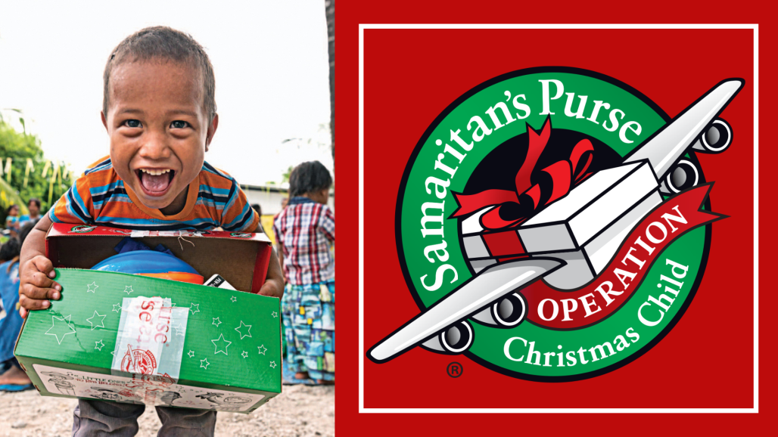
This November we will once again participate in Operation Christmas Child. Operation Christmas Child is a ministry where shoe boxes full of presents are packed here in the United States and then shipped around the world to be given to children.
All items in the boxes are new and they include toys, school supplies, clothes and hygiene items also included with each shoe box is a witness to the deep love of Christ for each child.
This year we are striving to pack 50 shoe boxes -in person or online.
If you wish to contribute toward our goal there are three ways to do so this year:
1) Build a shoebox online by going to-
https://www.samaritanspurse.org/operation-christmas-child/buildonline/
***If you make a box online please let us know.
2) Make a donation to the church of $30 per box we will build the box in your honor online. (You may drop a check or cash marked for Operation Christmas Child in the offering plate, or drop or mail a check to the church office).
3) Pack a shoe box personally. Beginning Oct. 19th, you can pick up a shoe box from the church and a pamphlet with directions, fill the box and return it by Sunday November 23rd.
However you choose to bless a child this Christmas know that you will bring great joy to the heart of each child and God will use you to speak his love and grace into the hearts of many in need of knowing the Father who loves them.
Peace in Christ,
Pastor Chuck

6


We’ve been enjoying the beautiful fall weather and have even had a few extra second snack times outside on our playground. It’s such a joy to see the children laughing, playing, and soaking up God’s wonderful world. During chapel each week, Pastor Chuck has been teaching us about God’s great love for us, and what a special time this is for our little ones.
Our students have also been busy practicing all through October for their fall performance, and we are so proud of how hard they’ve been working. As we move into November, we’ll be talking about thankfulness and making special Thanksgiving crafts. November also brings our annual Blue Ridge Area Food Bank food drive. This is such an important tradition for our preschool as we learn to share our blessings with others.
We are always thankful for the love and support our preschool receives from our church family. Donations of pre-packaged snacks such as Cheez-Its, Goldfish, pretzels, or crackers are always a wonderful help and greatly appreciated by our hungry little learners.
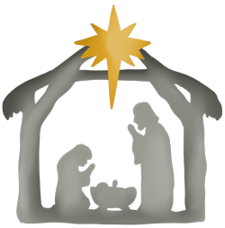
Once December arrives, our classrooms will be full of Christmas excitement. The children will be making festive crafts, handmade ornaments, and gifts as we celebrate the birth of Jesus together. We can’t wait to share in all the joy this special season brings.
Wishing you a season filled with joy, gratitude, and God’s blessings.
St. John’s Preschool Staff

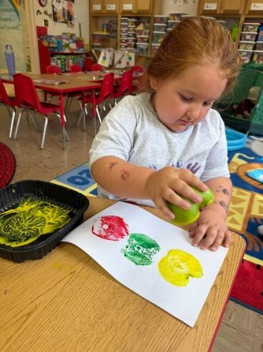
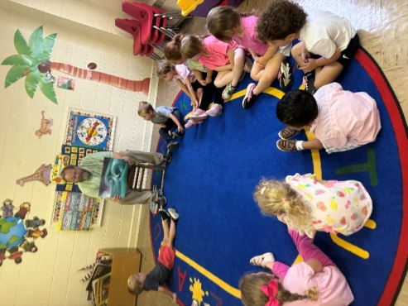
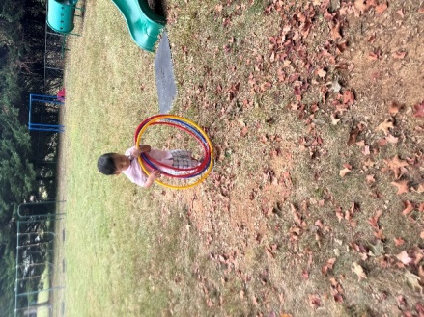

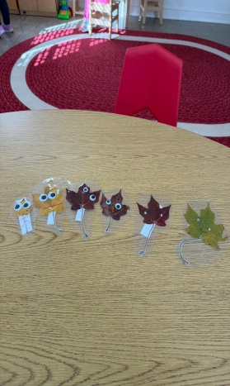
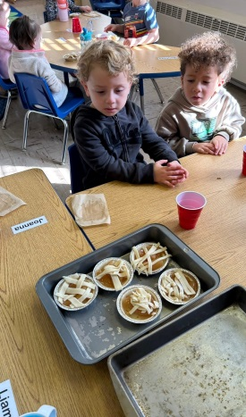

3

Church News



St. John’s Charge Conference will take place at Christ UMC (Staunton)
on Thursday, November 6th at 6:00pm. Attendance is encouraged by
those in leadership roles. Please contact Pastor Chuck if you can come
or have any questions.





The Trustees will be holding a Church Beautification Day on Sunday, Nov. 16th following worship. Volunteers are needed to help weed, trim bushes, rake leaves, etc. Lunch will be provided. Please plan to stay.

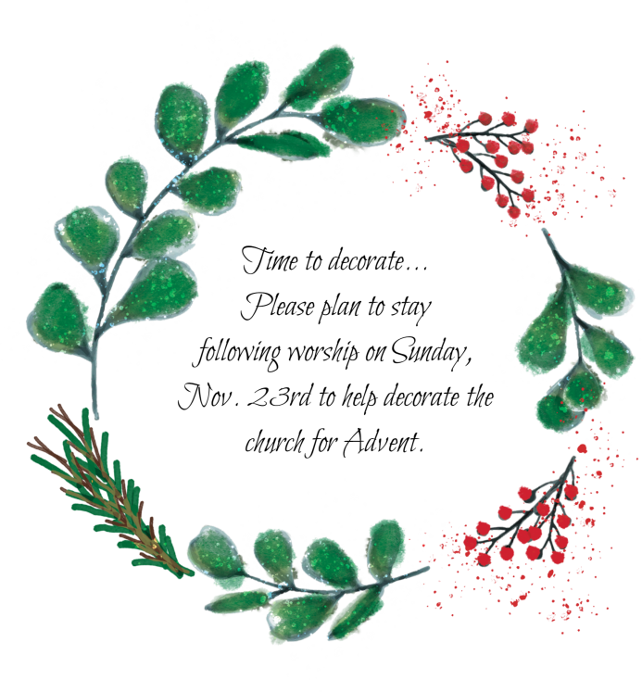
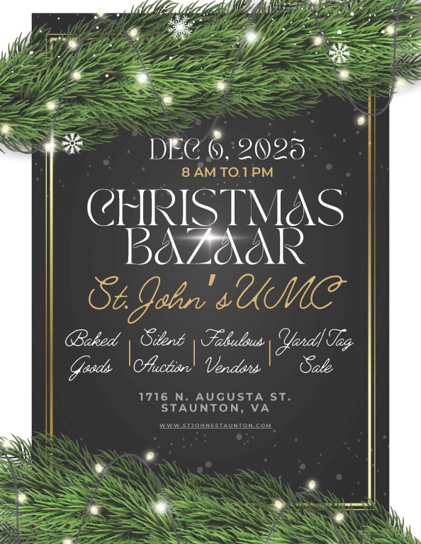

4

Trustees

You may remember that we announced a few months ago that we had sold the Jollivue property. Because of that, we are finally able to get a new roof here at St. John's. Yes, we will be replacing this 68 year old roof that has been leaking for many years! Holloway Roofing will be doing the work and we expect for that to start in the next few weeks.

As you know, our current roof is an asbestos tile roof and it will be replaced with a shingle roof. There will be a period of time of probably 4 days that no one will be allowed on the Church property while they are doing the abatement process. We will keep everyone informed by e-mail, announcements at Church and in the bulletin as to when this will happen.

We feel this is a real gift and an opportunity to make our Church more welcoming and be an improved facility for our ministry here at St. John's.

If you have any questions or concerns, please let me know.

Kim Harris, Trustees Chair


Finance Committee

For the month of September:

Deposits- $95,703.67
Expenses- $99,539.69 (transfer $75,343.40 to Edward Jones; $7,905 for pipe repair);
$2,938 for quarterly church insurance)

For the month of October (as of 10/20):

Deposits- $4,655.97
Expenses- $6,082.70

Our offerings on Sundays are still not enough to cover monthly expenses. Please continue to keep this in mind as you consider your giving.

Thank you for your consideration,

Kim Harris & Donna Elkins, Finance Committee co-chairs

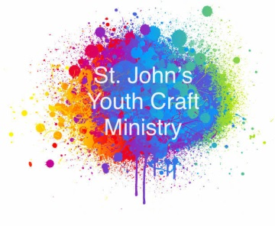
The St. John's Youth Craft Ministry (YCM) will begin meeting every other Sunday starting on Sunday, November 16th at 10am.The YCM is a group ranging in age from 3 to 15. Our mission is to connect our youth with God and the community through crafts, prayer, kindness, and service to others. Our group will be making crafts and donate them to organizations in need. For
more information, contact Hannah Gazmen at hgazmen2012@gmail.com.


Noisy Can Offering - Shade and Fresh Water Project
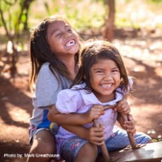
Bring your change or bills the first Sunday of each month for the
“noisy can offering.” To date the Youth have collected $637.52.
Thank you for your continued support.

5

