


5th- Sarah Cole
6th- Brenda Kirby
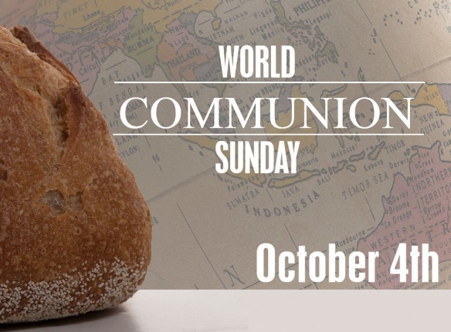
7th- Mike Hammer
8th- Daniel Cole
20th- Iris Carr
21st- Danielle Hammer
25th- Mark Jordan
26th- Ashley Wilcher
27th- Pat Fitzgerald, Hattie Markham




3rd- Allen Daughtrey
4th- Chris Markham
19th- Leah Pack
29th- Marion Taylor, John Pancake

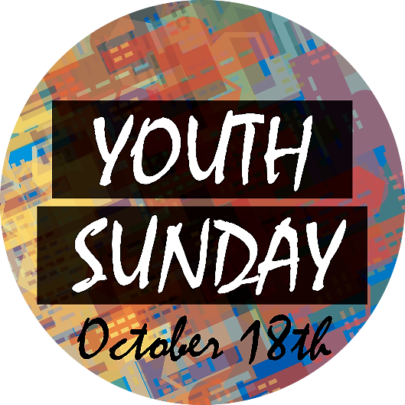
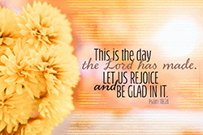

4
ST. JOHN’S UMC EPISTLE

SEPTEMBER/OCTOBER 2026
Pastor: Rev. Chuck Cole

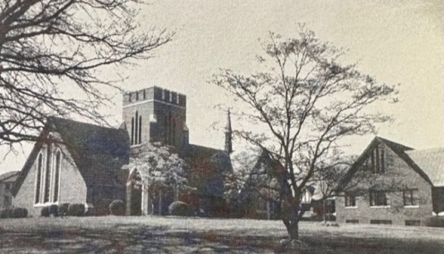
Table of Contents~
Page 2….Church News
Page 3….History
Page 4….Birthdays
Insert…..Calendars

1716 N. Augusta St.
Staunton, VA 24401
(540) 886-1500; stjohnsumc@verizon.net
www.stjohnsstaunton.com; facebook.com/stjohnsstaunton



This school year, St. John’s will be renting space to the Sacred Heart of Jesus Classical Academy, a small Roman Catholic High School. A small office and the two rooms across from the bathrooms in the youth wing will be reserved for students while the school is in session. They will also be utilizing the grounds, the kitchen, and the social halls during the school day while honoring the preschool’s ability to freely use spaces they require. They will also work flexibly with the church to facilitate our ministry. If you have any questions about this, please contact Kim Harris.



taken up by the Youth, the
first Sunday of each month. Year to date, the Youth have raised a total of $790.66. Monies collected will go to a mission of their choice. At present, the offering supports the International Justice Mission, a organization dedicated to protecting people in poverty from violence, slavery, and sexual exploitation. If you are in worship on the first Sunday of the month, please bring change or cash to put in the can as the kids collect it. Thank you for your continued support of this mission.
Pastoral Care Schedule~ The Noisy Can Offering is

Jim Harris – August 31st – September 14th
Jonathan Greer – September 15th – 21st

Preaching Schedule~

9/6 – Jim Harris (Holy Communion)
9/13 – Jim Harris
9/20 – Jim Harris
*Pastor Cole returns on September 23rd.
**Tuesday night Bible Study resumes on
September 29th at 6:30pm.


Finance Report- July/August (8/24):

Deposits- $13,500.40; Expenses- $26,119.02

Our regular tithes and offerings have decreased. Please continue to keep this in mind as you consider your giving. Thank you for your continued
Support of St. John’s.



St. John’s Preschool school year begins on
Sept. 8th. We still have several spots open. Please
contact Alissa at stjohnspreschool1@verizon.net
with any questions.

St. John’s Preschool Staff
2
BITS & PIECES~ SEPTEMBER-OCTOBER 2026
I thought I would take a break from the ministers and the Revolutionary  War. However, I’m still going back in time.  Do any of you know what is the oldest Methodist church in the Shenandoah Valley? It’s not here in Staunton. Stephens City UMC (originally in Stephensburg) holds the distinction of being the oldest Methodist congregation west of the Blue Ridge. Its beginnings are traced back to 1775. Originally, early circuit riders like John Hagerty and Richard Owens would meet in private homes. In 1789, a log meeting house was built followed by a brick church in 1827. The first building had gender-separated seating and was lit by horn candlelight and later oil lamps.  The Asbury congregation (now Asbury Downtown) in Winchester also claims lineage to the late 1700’s.  In 1789 a one-acre lot was purchased, and a log cabin meeting house was  erected. It may have looked a lot like  this…..  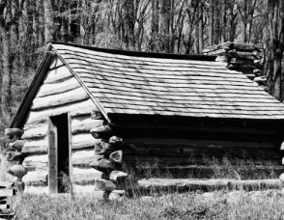  The oldest Methodist church building still in use in the country west of the Alleghanies is the Old Rehoboth  Church in West Virginia. (at the time it was built, it was still in Virginia) It was organized in 1784 and dedicated by Francis Asbury in 1786. Aside from the pulpit, the only furnishings in the church were the pews.  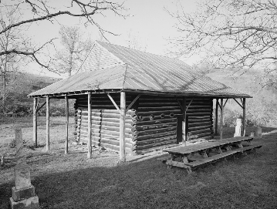 | Now, if you’re looking for the oldest one in Augusta County, it would be Central United Methodist here in Staunton. It was organized in 1797. It began in Sampson Eagon’s home on the corner of East Beverley and N. Coalter St. So many people came, they had to move to his blacksmith shop. Because of Eagon’s pray and song services, the neighborhood became known as Gospel Hill. It’s still known by that name today.  Around 1800, because neither his home nor blacksmith shop could  accommodate the grown number, a one-story building was erected on the present location of Lewis St.  While I’ve been going through some of Jollivue’s history, I found some of their newsletters. Since I don’t have all of their bulletins, I thought I would go through these newsletters and put some of the “what was happening” here.  This is from Sept – Oct, 1994.  -Zachary Taylor Hackett, was born  Aug 4. He is the son of Mark and  Laura Hackett.  -An ice cream social was held on  Aug 20. They received $226.00 from  donations towards their pavilion fund.  -Sept 17 was their Day of  Remembrance.  -Rev. Harlow took part in the closing  ceremonies of Kings Daughters  Hospital.  -Jacey Marie Hunt, daughter of  Kathy and Dale Hunt and great-  granddaughter of Mr. and Mrs. Peachie Riley was born on 4 Sept.  -On 16 Oct, Jollivue observed their 40th anniversary.  -The United Methodist Men were in  charge of the worship service on 30 Oct.  3 | WHAT WAS HAPPENING 25  YEARS AGO?  -Pre-school Open House was held 10  Sept.  -The church picnic was held on 15  Sept on the church lawn.  - Pledges started for the new sign out front on 2nd Sept. The cost was $3,000.  -The rosebud on the altar on 9 Sept was for Madison Dawn Shuler, daughter of Melisa and Kevin Shuler,  granddaughter of Rebecca Wilson and great-grandmother Ruth Hickman.  -Consecration Sunday was 30 Sept.  Guest speaker was Mr. Jim Branscome.  -On 7 Oct, Eric Fitzgerald delivered  the Children’s Message.  WHAT WAS HAPPENING  50 YEARS AGO  -On 18th of Sept, the Senior High  attended the Univ of Virginia football game. They were to bring a ‘sack  lunch and $1 for the ticket’.  -On 19th Sept, Dr. Roland Hohn was the guest speaker.  -10th of Oct was Homecoming at St.  John’s  -Maurice and Sue Harrison and family joined St. John’s on 10 Oct.  -On 18th of Oct, Lib Sterrett passed  away.  -On 17th Oct, Bob and Jeanne Partridge and family joined St. John’s  -On 19 Oct, Pamela Kayuu Mace,  daughter of Mr. & Mrs. Raymond Mace was born.  -Autumn shows us how beautiful it is to let things go.  -Fall is a Southerner’s reward for having survived summer.  -Fall, the beautiful time of year between heat stroke and frostbite.  -A fallen leaf is nothing more than a summer’s wave goodbye.  Have a hot cider, prop your feet up and enjoy God’s paintings.  Cindy Phillips |   Cindy Phillips

