


11th- Charlie Cole
22nd- Sara Sochor
25th- Kim Harris




5th- Amanda Riley

9th- Grace Daughtrey, Charlie Myers
11th- Betty Hairfield
14th- Rosemary Budzynski
16th- Hank Budzynski
22nd- Mary Anne Bennett
25th- Linda Hamrick, Jan Humphries, Patsy Myers
27th- Alex Daughtrey
28th- Lori Lewis
30th- Jim Huggins



8
ST. JOHN’S UMC EPISTLE

MARCH/APRIL 2026
Pastor: Rev. Chuck Cole
Table of Contents~
Page 2….From the Pastor
Page 3….Preschool News
Page 4….Church News
Page 5….Church News
Page 6….This and That
Page 7….History
Page 8….Birthdays
Insert…..Calendars

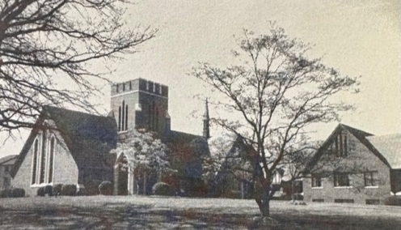

1716 N. Augusta St.
Staunton, VA 24401
(540) 886-1500; stjohnsumc@verizon.net
www.stjohnsstaunton.com; facebook.com/stjohnsstaunton


Dear Brothers and Sisters of St. John’s,

By the time you read this article we will be well into the season of Lent preparing for Easter on April 5, 2026. It is my prayer that as you are walking through this season you take advantage of the opportunity to evaluate how you are allowing the Holy Spirit to form you towards Christ though the Means of Grace that he has given us.

I encourage you this Lent to consider what your study, giving, prayer, service, witness and worship practice builds in you and what signals it sends to those who look to you for guidance and wisdom. Whether you are a friend, neighbor, fellow church member, customer, parent, teacher the ways that we interact with our spiritual lives and the fruit it produces in us is powerful in not only our own lives but also in the lives of others. As you consider if you see places where a change in your pattern of practice - be it in giving, worship attendance etc would help you and others ask the Lord for the wisdom and strength to make the change in a way that is a blessing to all. As you seek to be more and more like Him in this way lean on his love and grace.

Good Friday April 3rd we will be having a joint Good Friday service with Christ UMC here at St. John’s please mark your calendar and make this powerful day a part of your Lenten/Easter disciplines. Often, especially in protestant churches, in the US we go straight from Palm Sunday to Easter. In this we miss out on the power of the terrible goodness of Good Friday, and the awkward waiting of Holy Saturday. These Holy Days increase the impact of the Joy of Easter which we will celebrate with worship on Easter Sunday morning and then with our Easter Feast to follow.

Praying for you all that you experience a Blessed Lent and Joyous Easter.

In Christ,
Pastor Chuck Cole




2
BITS & PIECES~ MARCH-APRIL 2026
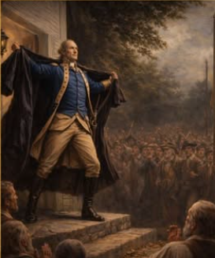  This being the United States 250 anniversary, I have been getting a lot of information thru the DAR. Some of these, I have found very interesting and am sharing one of these here.  This picture is of Rev. Peter Muhlenberg. He was born in Pennsylvania in 1746, the son of a German Lutheran pastor.  He received some education in Germany before returning to Pennsylvania. He then served briefly in the British Army earning the nickname “Devil Pete” before returning to Philadelphia to continue his education at the Academy of Philadelphia (now the University of PA). He was ordained in 1768, headed a church in New Jersey before moving to Woodstock, VA.  He visited England in 1772 and was ordained in the Anglican Church although he served a Lutheran congregation. Since the Anglican Church was the state church of Virginia, he was required to be ordained to service in a congregation in Virginia.  After the war broke out in 1775, Muhlenberg was authorized to raise and command the 8th Virginia Regiment as its colonel. He was likely chosen because of his influence of the German-American community. (Interesting note – of the 8 colonels in the Virginia Line, he was the youngest at 29 and only | Patrick Henry had less military experience.  He was a plain, straightforward speaker, well suited to the people of his congregation. According to a biography written by his great-nephew in the mid-19th century, on 21 January 1776 at the Lutheran Church in Woodstock, Muhlenberg took his sermon text from the 3rd chapter of Ecclesiastes which starts “To every thing there is a season…” and after reading “a time of war, and a time of peach”, he declared, “And this is the time of war” removing his clerical robe to reveal his Colonel’s uniform. Outside the church within a half an hour, 162 men were enrolled. The next day he led 300 men from the county to form the nucleus of the 8th Virginia Regiment.  He served in several battles up and down the East Coast. At the end of the war, he was brevetted to major general. He felt he could not return to being a parson after have been a soldier. He surveyed military bounty lands assigned to Virginia veterans, traveling as far as Louisville, KY but turned to his native Montgomery County, PA.  For the remainder of his life, he served his country as an elected official. He died in 1807.  I’ve also wondered how the American Revolution affected the Methodist Church. Remember, during this time, it was the early days of the church. John Wesley was opposed to the rebellion. While Wesley and many British-aligned leaders | were loyalists, American Methodist followers were split. Many adopted a position of neutrality, pacifism, or in some cases, active Patriot support.  Due to Wesley’s stance, Methodists were often viewed with suspicion in the colonies, leading to persecution of preachers and many, including Francis Asbury, having to go into hiding or returning to England.  WHAT WAS HAPPENING 25  YEARS AGO?  - There was an insert in the bulletin of the hymns being sung that day and each one had a bit of history behind it.  - The church held an old-fashioned hog butchering (the hog was already dead) to celebrate Valley History Celebration on 31 Mar.  - On 1 April, the Rockingham Male Chorus performed at St. John’s  - The kids of the pre-school sang during the worship o 29 April.  50 YEARS AGO  - 4 April, the Alleluia Singers from Georgia presented a program at St. John’s  - On 11 April, there was a notice in the bulletin that the St. John’s basketball team finished the season as league champs with a 10 – 2 record.  - On 18 April, the following Confirmation class was welcomed as members – Hunt Dekle, John Herndon, Alison Painter, Ronald Painter, Tomas Rosen, Jan Shaver and Rebecca Tanner.  - It’s one of those March days, when the sun shines hot, the wind blows cold, when it’s summer in the light and winter in the shade.  - In the spring, at the end of the day, you should smell like dirt.  Cindy Phillips
7
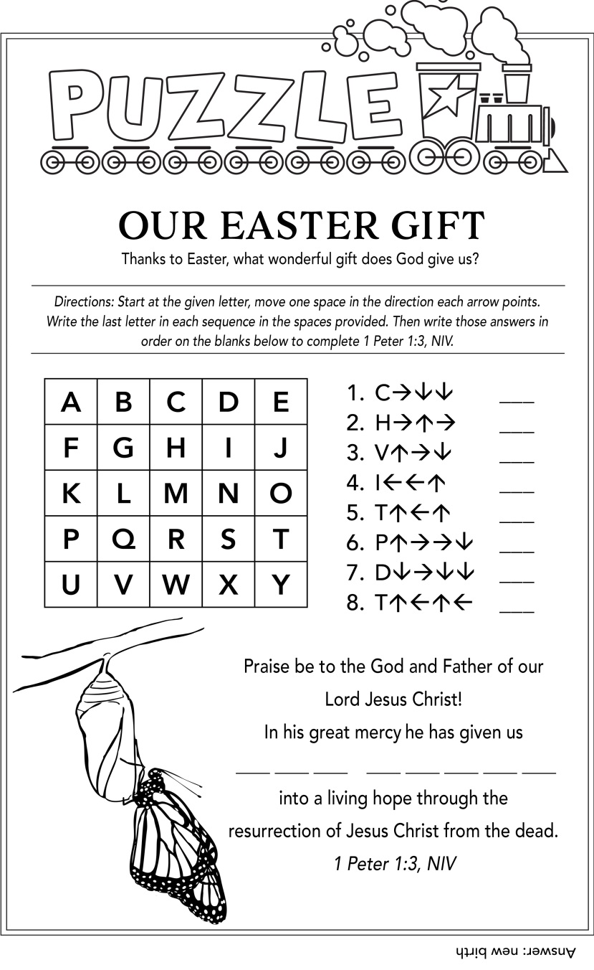
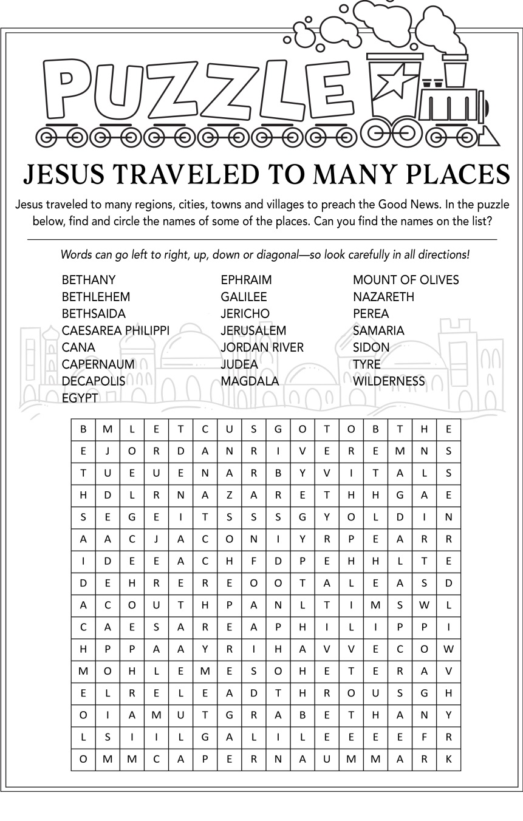



Resurrection Cookies~
The process of making Resurrection cookies is a wonderful way to share the Easter story. Each step and ingredient represents a part of the story and the final product. The cookie is a representation of the empty tomb that was found on Easter morning and the meringues cook so that the middle is hollow.

Ingredients-

•1 cup pecans or mini chocolate chips •1 tsp vinegar •Pinch of salt
•1 cup of sugar •3 egg whites

Instructions-

Preheat oven to 300 degrees. Place pecans in plastic bag and crush. Add vinegar, egg whites, salt and sugar into mixer. Beat until egg whites are stiff (5-10 minutes). Fold in nuts and/or chocolate chips. Cover cookie sheet with parchment paper. Place meringue by spoonful onto baking sheet. Place into hot oven and turn OFF. Keep the door shut and allow to sit overnight. Open the oven Easter morning and enjoy a cookie!
6


We have so many exciting things happening at St. John’s Preschool. We have missed some school due to the snow and ice. Everyone is looking forward to the upcoming season and the weather it will bring.

Registration for 2026-2027 is open. If anyone has friends or family with a child between 2 ½ and 4 years old and is interested in a spot at St. John’s, please let us know or contact the church office.

March begins with a celebration of Read Across America! We will dress up as our favorite book character to celebrate. We will also visit The Legacy of North Augusta to celebrate St. Patrick’s Day. Keep an eye out on our school Facebook page for what I know will be some adorable pictures of the kids celebrating.
We will learn about St. Patrick and how he used the shamrock to teach about the Trinity. We will have a St. Patrick’s Day treasure hunt, party and create many crafts.

In April this year we will tell the Easter Story. A couple of our Easter activities include a Palm Parade and our Easter Egg Hunt & Party.



Happy spring!
St. John’s Preschool Staff

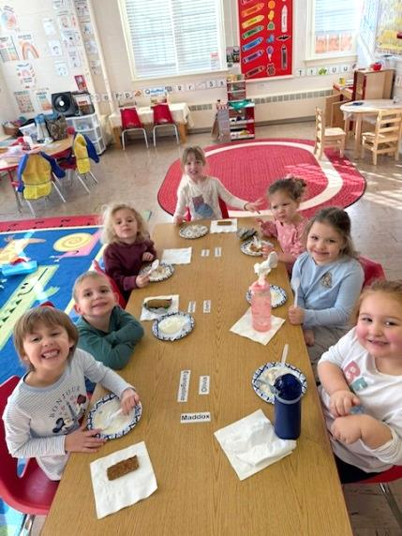
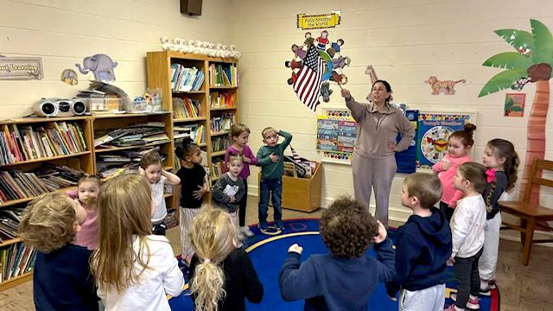
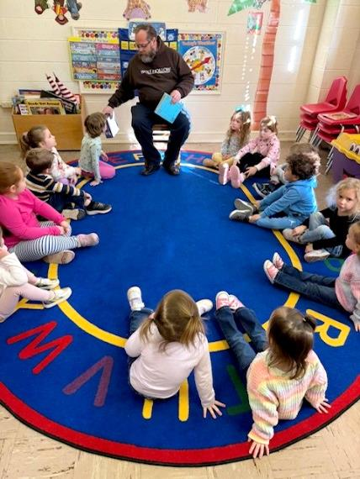

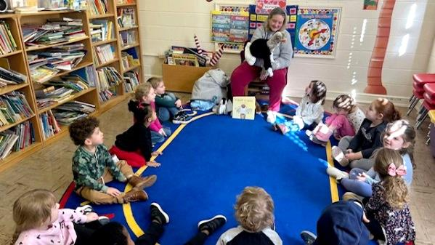

3


Church News

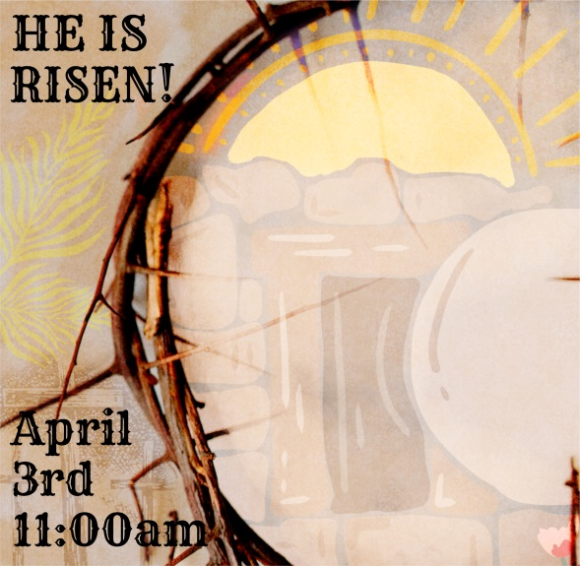
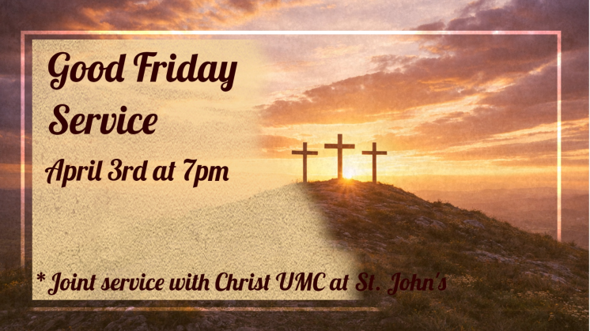


Trustees

Since we now have a new roof and the cost of that was covered by the insurance company, we are ready to start making some other repairs and up-grades to our Church. We have been busy getting estimates for painting, flooring, replacement windows, parking lot paving and even the possibility of a new boiler!
The first phase of this will be repairing and painting all of the interior water damage from the leaking roof as well as other interior painting. Painting began in the main Social Hall and kitchen on Monday, Feb.23. We will also be painting the Youth Social Hall, hallway from the main Social Hall to the sanctuary, office, choir rooms, narthex and parlor. Stay tuned for more up-dates as we proceed!

We have also replaced the three light fixtures and bulbs that shine on the bell tower as well as the timer in the attic for those lights (total cost of $1,000). During the week that we hosted the WARM shelter, we also had to have Speedy Rooter come to clear out big clogs in a few of the toilets in the hallway near the Youth Hall (total cost $700).

Kim Harris, Trustees Chair
4

St. John’s hosted the WARM Shelter from February 9th-17th.
Founded in 2011, WARM organizes a cold weather shelter as
well as transitional housing and outreach programs. As the
host church, along with other local churches & organizations,
we provided and served breakfast, lunch and dinner. Thank you to each and every one of you who volunteered your time during this week! If you would like to learn more about the WARM shelter, please visit their website at warmwaynesboro.org.


From the Family Committee:

I want to send out a huge thank you not only to the Family Committee, but to all of those who contributed time, donations, meals and prayers. This is a very important and needed mission that we can help with and we could not have done it without all of your support. Thanks again.

Cindy Phillips
Chair of the Family Committee


I just want to make sure that the congregation of St. John's knows how lucky we are to have the kids that we have here. In case you were not aware of this, the Youth Craft Ministry kids donated the money they made from the yard sale at the Bazaar to purchase a meal for the folks at the Warm Shelter. The meal was lasagna, salad, garlic bread and cookies. And there wasn't much left.

Secondly, the weekend before the Warm Shelter, the youth group spent at least 2 days carving the snow out of the back courtyard. This included shoveling the steps going up to the Youth Social Hall, the walkway to the hall door and getting rid of the glacier that was on the steps going down to the boiler room. This had to be cleared before the folks from the Warm Shelter arrived due to the fact that the boiler is in that room and so is the main shut off for the water. I know they worked hard on that because I was here when Amanda and the kids were working. And they worked until almost dark.

We, as a church, are truly blessed to have the kids we do and how hard they work.

Cindy Phillips

5

