

15th- Marshall Kirby
16th- Rick Maryman
23rd- Clinton Fitzgerald
24th- Bruce Frank




4th- Pam Huggins
17th- David Zullig
22nd- Loretta Muncy
25th- Cindy Phillips
27th- Hoye Muncy


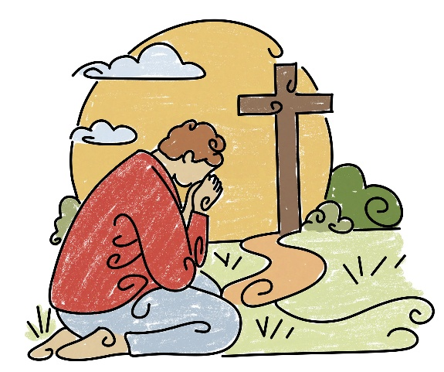

8
ST. JOHN’S UMC EPISTLE

JULY/AUGUST 2026
Pastor: Rev. Chuck Cole
Table of Contents~
Page 2….From the Pastor
Page 3….Church News
Page 4….Mark Your Calendar
Page 5….Preschool News
Page 6….History
Page 7….Bits and Pieces
Page 8….Birthdays
Insert…..Calendars

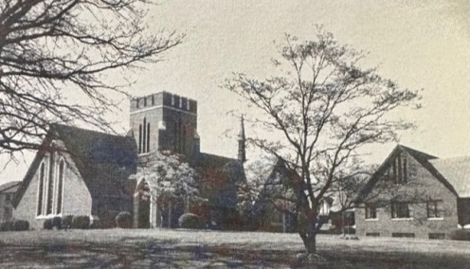

1716 N. Augusta St.
Staunton, VA 24401
(540) 886-1500; stjohnsumc@verizon.net
www.stjohnsstaunton.com; facebook.com/stjohnsstaunton


Dear Brothers and Sisters of St. John’s,

I am writing to you at a time when we are approaching the 250th anniversary of the founding of the United States. We appropriately give thanks to God for his grace and his mercy toward us as we move toward a more perfect union.

While we are thankful for all his blessings including our nation, our hope is not in the United States but in the Lord and the coming Kingdom of God. Not only is He and his Kingdom the Hope for us but for the whole world.

As those of us in attendance at Annual Conference were reminded our mission is to proclaim the Good News of Jesus Christ to the world calling people into relationship with him.

We do this by using our prophetic imagination - seeing the world that God in Christ is bringing into being as he makes all things new. We do this by seeking through the sharing of the Good News of the hope we have in Christ by words that clearly proclaim and actions that enflesh the Hope of the Gospel for the world.

(If you want to hear about the importance of both words and actions, ask me sometime about the vegetarian story.)

We live in a world which is often tiring and makes our ability to act for the Kingdom hard and can dull our imaginations.

Let us as a people and each other hear and take hope and do the words of Paul in Galatians

⁹ Let us not become weary in doing good, for at the proper time we will reap a harvest if we do not give up.¹⁰ Therefore, as we have opportunity, let us do good to all people, especially to those who belong to the family of believers.

As we walk through these days let us seek strength and rest in him so that we can love the world and all the people that he died for in all the ways he places before us and calls us into.

In Christ,
Rev. Chuck Cole

Pastoral Care Schedule~ Preaching Schedule~

Brett Isernhagen - July 27- Sunday August 9th 8/2- David Rash (Holy Communion)
Tizzy Walker - August 10th-23rd 8/9- David Rash
Jonathan Greer - August 24th - 30th 8/16- Alan Combs (Holy Communion)
Jim Harris - August 31- September 14th 8/23- Bill Bearden
Jonathan Greer - September 15-21 8/30- Bill Bearden
9/6 - Jim Harris (Holy Communion)
9/13 - Jim Harris
9/20- Jim Harris
2
BITS & PIECES~ JULY-AUGUST 2026
I was trying to find out more about Methodism in the valley during the American Revolution. Found some real interesting things.  Methodism first expanded into the Shenandoah Valley in the 1770’s. Early itinerant preachers formed massive, multi- county circuits through the region. There were three early Methodist circuits.  The Berkeley Circuit was formed around 1778 and originally included all of Frederick County, a massive “mother county” which encompassed much of the surrounding northern VA region and adjacent parts of WV with Winchester serving as its administrative center.  The preachers, John Hagerty and Richard Owens visited the Stephensburg (Stephens City) area in 1775. This led to the formation of a local society that is widely recognized as the oldest Methodist congregation west of the Blue Ridge Mountains. A log meeting house was later constructed in 1788.  In 1786, the Methodists purchased a one-acre plot near the Red Banks on the Shenandoah River, eventually building the Bethel Ford Meeting House (Mt. Jackson).  These meetings eventually transitioned into Camp Meetings and Revivals. While the camp meetings became distinctly Methodist led by people like Bishop Francis Asbury, the earliest regional revivals were often gatherings led by both Methodist and Presbyterian pastors.  Beginning in the last 18th century, these multiday outdoor gatherings were held in clearings or brush arbors, featuring emotional, hours long worships characterized by trances, visions and mass conversions.  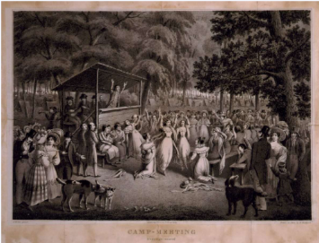  This 1829 lithograph depicts an ecstatic group of believers, many of them | women, responding to an evangelical preacher.  Even during the early stages of the American Revolution, the Methodists witnessed emotional church gatherings full of penitents calling out for God’s mercy. One Methodist itinerant wrote of meeting where “hundreds fell to the ground and the house seemed to shake with the presence of God”. These assemblies included not just whites but throngs of blacks, many of whom may have been attracted by Wesley’s stance against slavery.  Because of the 1775-1776 revival, the number of Methodist, just in Virginia grew from 2,600 to 4,400 in a year.    Emerson L. Deitz Sr.  22 Oct 1935 – 21 Apr 2026  While Emerson had not been a member of St. John’s for a while, everybody knew him. He was very active with the choir and the music direction of St. John’s. Please keep Nancy and their family in your prayers during this time.  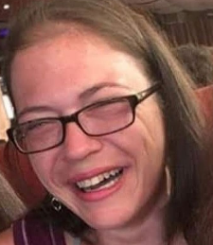  Jimie R. Taylor  6 Feb 1982 – 29 May 2026  Please keep Marion Taylor and her  family in your thoughts and prayers at the passing of her daughter, Jimie. As was said in her obituary, she persevered though her life’s challenges. She is now at peace.  7 | Congratulations to Al and Kaitlyn  Hammer who were married on 30 May. Proud parents are Mike & Gwen Hammer.  WHAT WAS HAPPENING 25  YEARS AGO?  - On 25 June, George W. Goodrow Jr  . passed away.  - On 30 June, Maxine Smith passed  away  -On 24 Aug, a chicken BBQ and  auction was held at St. John’s  WHAT WAS HAPPENING  50 YEARS AGO  - On 10 July, Lucinda Kiracofe and Mark Lentz were married at St. John’s. She is the daughter of Leon and Jodi Kiracofe  - James Mathew Watson, son of Mr. & Mrs., Thomas Watson and grandson of Mr. & Mrs. John Watson was born on 11 July.  - On the 17th July, Kathleen Wayne and Lloyd Smith were married in the courtyard at St. John’s  - Mathew Robinson, son of Mr. & Mrs. Robert Robertson was born 30 July  - Karla Garletts, daughter of Mr. & Mrs. Jon Garletts and granddaughter of Mr. & Mrs. Keith Garletts was born 31 July  - On 14th Aug, Carolyn See and Edward Van Dyke were married at St. John’s  - 29th of Aug was promotion Sunday here at St. John’s  Deep Summer is when laziness finds respectability!  Have a great summer  Cindy Phillips


"Two hundred fifty summers,
two hundred fifty winters,
and still the rivers sing.
Mountains stand like guardians,
fields breathe in the morning light,
and voices — many, different,
rise together in one song.
We are the echo of yesterday,
the promise of tomorrow,
and the heartbeat of today."

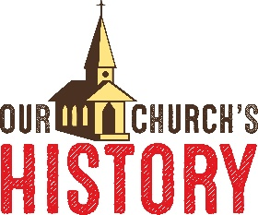

St. John’s Pastors-
Rev. Fletcher W. Swink- 1954-1958 Rev. Donald N. Fridinger- 1985-1989
Rev. Frank L. Baker- 1958-1961 Rev. James R. Cooke-1989-1993
Rev. Elmore Brown- 1961-1963 Rev. W.S. “Zig” Volskis- 1993-1996
Rev. Samuel A. Stanley, Jr.- 1963-1970 Rev. Donald Wilson- 1996-1999
Rev. Edwrd A. Plunkett- 1970-1971 Rev. Richard H. Ecklund- 1999-2002
Rev. Jenus G. Long, Jr.- 1971-1975 Rev. Steven W. Greer- 2002-2008
Rev. Edward M. Ridout- 1975-1979 Rev. Dr. Patricia Meadows- 2008-2013
Rev. Charles M. Walton- 1979-1982 Rev. Taylor C. Mertins- 2013-2017
Rev. John Bartee, Jr.- 1982-1985 Rev. Charles “Chuck” H. Cole, Jr.- 2017-
6




The Trustees have continued with improvements to our Church building. We have completed all of the interior painting as well as the exterior painting. The new vinyl tile floors have been installed in both Social halls, kitchen, office and the hallway from the Social hall to the Sanctuary. In the next few weeks, we will have replaced all of the windows in the Church, except for the Sanctuary windows, which were painted. We hope this will help with our energy bills.
We also installed an additional A/C unit in the main Social Hall to replace the one that had not been working for many years. At the same time, the A/C units for the Sanctuary quit working. They were installed 37 years ago, so have lasted a long time! The new units are being installed this week, so we can once again worship in the Sanctuary. We also added duct work in the kitchen, so there is now central air there. And finally, we installed a mini split wall mount unit for the office that will provide A/C and heat.

We hope you have an opportunity to see all the results of these projects!

Kim Harris, Trustees Chair


Finance Report:

Year to Date-

Deposits- $250,049.52 (of this amount- $176,000 was for Capital Improvements;
$25,000 was deposited from the Foundation account to
help with everyday expenses. Average monthly offering
is $8,174.92)
Expenses- $231,189.33 (of this amount- $153,687.03 has been spent on Capital
Improvements; Average monthly expenses is
$12,917.05)


Noisy Can Offering

The Noisy Can Offering is taken up by the youth, the first Sunday of each month. The offering supports a mission of their choice. At present, the offering supports the International Justice Mission (IJM) which is a global
Christian non-governmental organization (NGO) dedicated to protecting people in poverty from violence, slavery, and sexual exploitation

Please prayerfully consider how you might support this outreach. If you are in worship on the first Sunday of the month, please bring change (makes a fun sound when it clinks in the can), or cash to put in the can as the kids collect it. You may also give to the noisy can offering online at the website or put an offering in the offering plate another Sunday please just note in either case that it is for the Noisy Can Offering.

3



Rainforest Falls VBS 2026~
July 6th – July 9th from 9:00am-12:00pm
at Christ UMC, 1512 Churchville Ave,
Staunton
*3 years old to rising 6th graders
Step through the mist into Rainforest Falls, overflowing with
wild waterfalls, towering trees and colorful creatures. Beneath
a canopy of chattering birds and howling monkeys, kids plunge


into a life-long adventure, discovering the nature of God, and
exploring what it means to be rooted in relationship with their

creator, a safe place in life’s storms.

Register by scanning the QR code

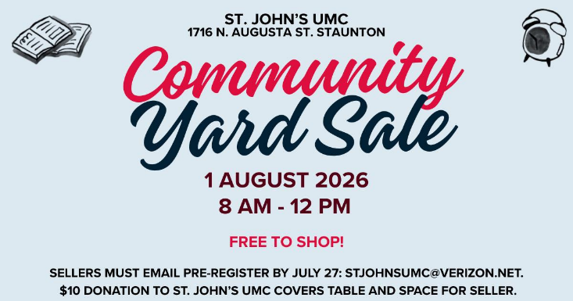
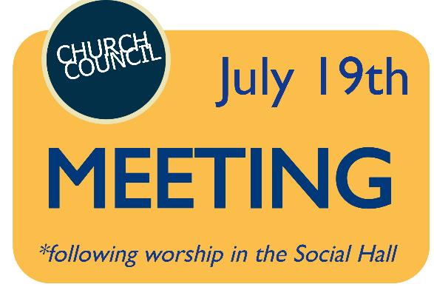




4


St. John’s Preschool finished off a fantastic year in May and we are already looking forward to starting back up in September. Registration for the upcoming school year is now open. We are currently enrolling students in our Two- and Three-Year-Old and Four Year Old classes. If you know a family looking for a nurturing environment where children grow in faith and learn about God’s love, we would be grateful if you shared our preschool with them. Please contact Alissa Jones at stjohnspreschool1@verizon.net if you have any questions.
We are so thankful for our St. John’s Church sponsor and the continued support that makes all of these experiences possible for our students.
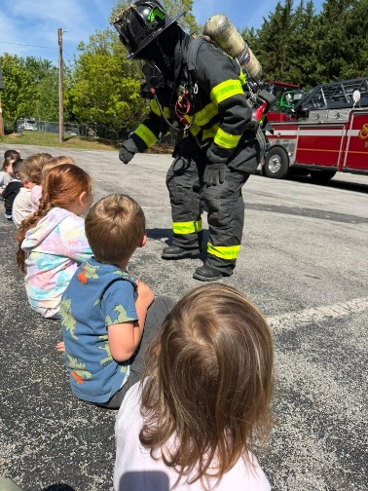
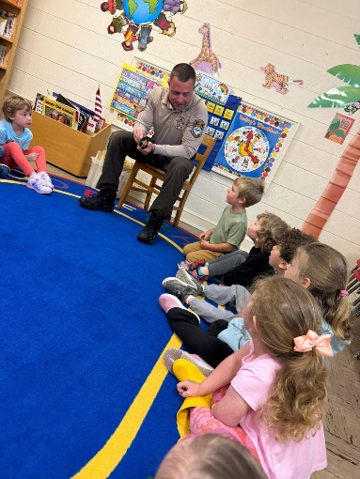
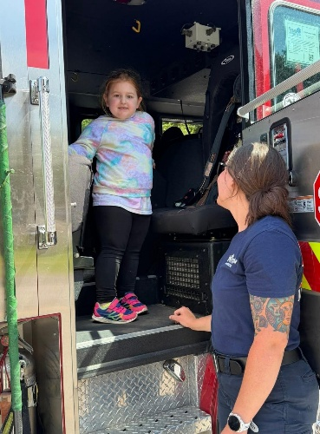

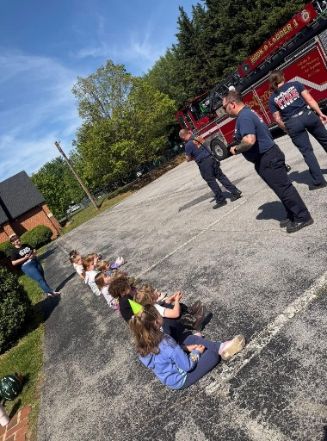
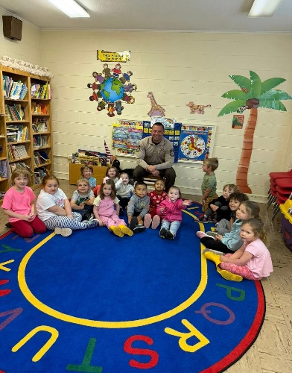
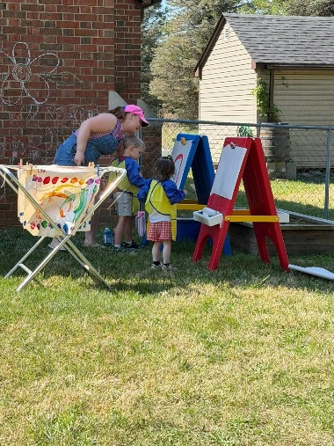

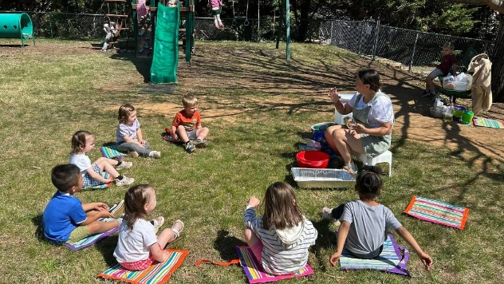
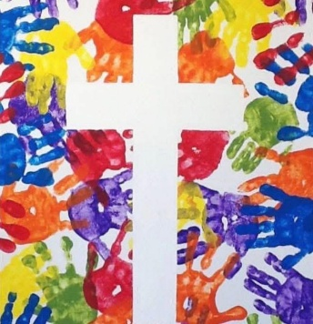

Happy summer!
St. John’s Preschool Staff

5

