


1st- Denny Hughes, Keeler Chapman
11th- Kristen Daughtrey,
16th- Tony Redifer
18th- Robert Reid

21st- Luken Mason, Dede Redifer
22nd- Kenneth Kirby
29th- Maurice Smith, Jr



1st- Joanne Campbell
6th- David Coleman, Jimie Taylor
7th- Karen Hamrick
10th- Linda Pancake, Jim Hodge

18th- Courtney Markham
19th- Vicky Mausen
20th- Evalee Cole
23rd- Elizabeth Coleman
24th- Yvonne Hanrick
26th- Holt Markham, Albert Deaver, Jr,
Cathy Ralston Fretwell




8
ST. JOHN’S UMC EPISTLE

JANUARY/FEBRUARY 2026
Pastor: Rev. Chuck Cole
Table of Contents~
Page 2….From the Pastor
Page 3….Preschool News
Page 4….Church News
Page 5….Church News
Page 6….Photos of New Roof
Page 7….History
Page 8….Birthdays
Insert…..Calendars

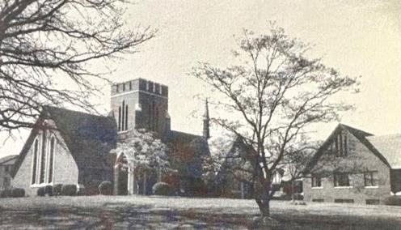

1716 N. Augusta St.
Staunton, VA 24401
(540) 886-1500; stjohnsumc@verizon.net
www.stjohnsstaunton.com; facebook.com/stjohnsstaunton

St. John’s UMC

1716 N Augusta St
Staunton, VA 24401



Brothers and Sisters of St. John’s,

We start the year of our Lord 2026 with a sense of optimism as we see the new roof that covers the church building where we worship and serve. This winter the Lord will use the space covered by that new roof to host worship of him in prayer, preaching, song and sacrament. He will provide education and spiritual growth of the students in our St. John’s Preschool (which is operating at capacity), to provide education and fellowship in Elementary, Youth and Adult Sunday School, Tuesday night Bible Study, Thursday Morning Lectionary Bible Study and Adult Sunday School. Youth Craft Ministry and Quilting for a cause will provide fellowship and the opportunity to serve others through gifts of creating under this roof. Outside groups such as PEACH homeschool youth gatherings (which several of our youth attend and Amanda Riley leads) will continue to use the building along with other community groups and events. We will of course continue to share in worship, fellowship and service in each and every area of the building.

Among the opportunities we have this winter is to share and witness to Christ’ love in the hosting of the WARM Shelter for those dealing with homelessness. We will host WARM from February 9th - 16th. As part of hosting WARM there will be numerous opportunities to serve both before and during the week. Cindy Phillips will be coordinating the breakfast, lunch and dinner we need to provide. Along with meals we will need one person from the church to stay overnight each night, quarters are needed to help those staying to do laundry ($5-$10), gift cards ($5-$10) in value to businesses in the area as a reward for their Thursday night Bingo game. Along with all of this there are opportunities for congregation members to be present with the guests to eat with them, to play games with them, to get to know them and pray with and for them in many cases. Please be praying and considering how you might serve the Lord via the WARM shelter through giving of your time and resources please be on the lookout for specific opportunities.

We are thankful for the way the Lord will use this congregation and the building which he has provided for his Glory in these winter months. Please be in prayer also as we discern how else in terms of improvements and ministries to make St. John’s an efficient and welcoming place to serve and honor the Lord in.

In Christ,
Pastor Chuck

2
DID YOU KNOW???? - January – February 2026
I was contemplating what to write about for this article when I noticed an article on my DAR chapter’s Facebook page. After reading it I thought you might find it interesting. Especially since our country will be celebrating its 250 birthday this year.  Did you ever wonder how the preachers got paid in the 1700’s? Well, maybe this will help. In colonial Virginia, the salaries of the Anglican clergy were paid by the taxpayers. Since the year 1758, the salary had been set at 16,000 pounds of tobacco per year. (That amount of tobacco was worth £144 in British sterling. Today that amount is worth approx. 40,000 to 41,600 sterling which is $53,516.00 in US dollars).  Now after a severe drought in 1758 that resulted in a poor crop, the price of tobacco tripled. To pay the ministers their usual allotment of tobacco would have to be tripled. This would have been hard on the rest of Virginians during the economic hard times. So, the Virginia legislature enacted a law that the allowed the pastors to be paid in paper money at a rate equal to the normal price of tobacco. The clergy complained to the crown and King George III invalidated the law, encouraging the ministers to sue for back pay.  In 1763 Rev. James Maury brought suit in Hanover County seeking lost wages. Given the royal veto, the trial judge agreed that the law had been violated and he empaneled a jury to determine the amount of damages to be paid.  Now, was there any lawyer in his right mind to oppose the King and church? Oh, yes…a young lawyer from Hanover County agreed to just that. Patrick Henry’s closing argument launched him on his brilliant career. First, he went after the clergy. “We have heard a great deal about the benevolence of our reverend clergy, but how is the manifested? Do they manifest their zeal in the cause of religion and humanity by practicing the mild and | benevolent precepts of the Gospel of Jesus? Do they feed the hungry and clothe the naked? Oh no gentlemen? Instead, these rapacious harpies would, with their powers equal to their will, snatch from the hearth of honest parishioner his last hoecake, from the widow and her orphan child their last milch cow! The last bed, nay, the last blanket from laying-in woman!”  Then he turned on the King himself. “A king, by annulling or disallowing laws of this salutary nature, from being the father of his people, degenerates into a tyrant, and forfeits all right to his subjects’ obedience.”  Now you know the spectators gasped and some even cried Treason. Of course, this was not the last time a Patrich Henry speech would have such an effect. The jury deliberated briefly and returned with their verdict. They awarded Rev. Maury one penny in damages.  Patrick Henry argues the Parson’s case 262 years ago this past Dec. 1.  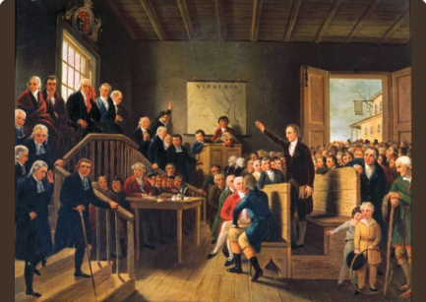  This painting is “Patrick Henry Argues the Parson’s Cause” by George Cooke in 1834  ***************  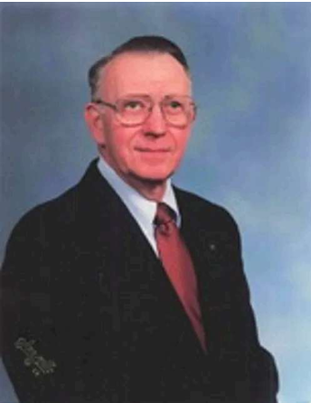  Russ Jordan  30 May 1929 – 9 Nov 2025 | We have lost another long-time member of St. John’s. A quiet man who enjoyed life, politics and talking with people, Russ and his wife, Helen attended St. John’s for many years until health issues got in the way.  He and his wife did go to another church while they lived in Bridgewater, but his heart was always with St. John’s. Please keep Mark, Stephen and the rest of the family in your prayers.  ***************  WHAT WAS HAPPENING 25  YEARS AGO?  On Jan 21, the youth went snow tubing.at Ingleside.  25 Feb was Transfiguration Sunday  WHAT WAS HAPPENING 50  YEARS AGO  25 Jan, the Gartlett family joined St. Johns.  25 Jan was also Human Relations Day  8 Feb there was a plea for extra hymnals for the Church. They cost $6.00 each.  29 Feb – Dr. Frank H. Van Dyke, District Superintendent was guest speaker  ***************  - The best way to predict the future is to create it.  - Jan 1st is the first blank page of a 365-page book. Write a good one.  - February is the border between winter and spring  - In February, there is everything to hope for and nothing to regret.  Hope everyone of you have a fabulous New Year!  Cindy Phillips
7
**Out with the old, in with the new. Courtesy of Holloway Roofing.
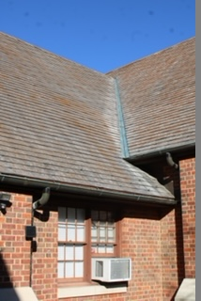
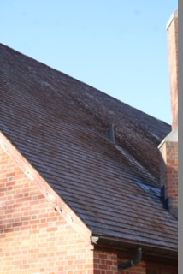
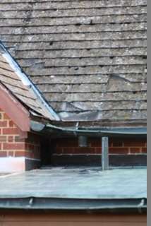
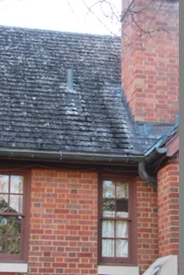
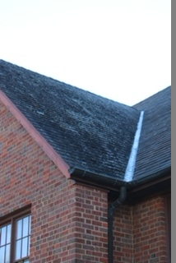

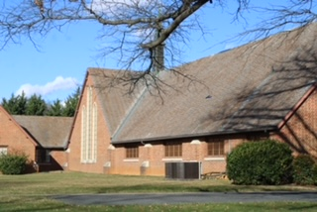
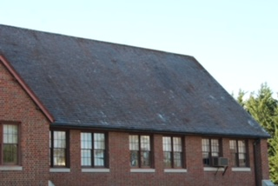
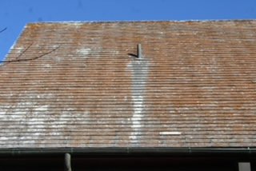
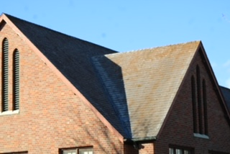

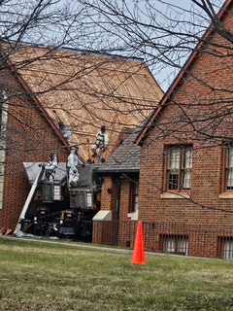

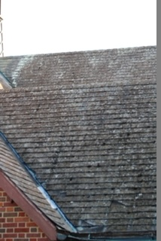
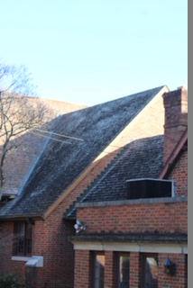
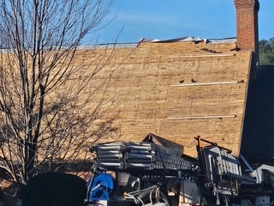

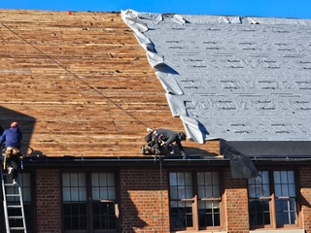
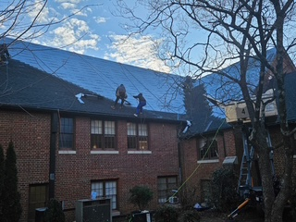
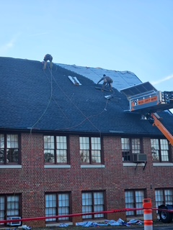
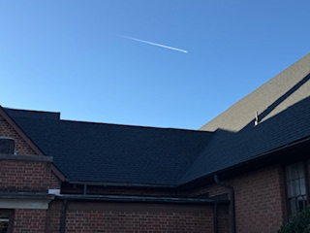

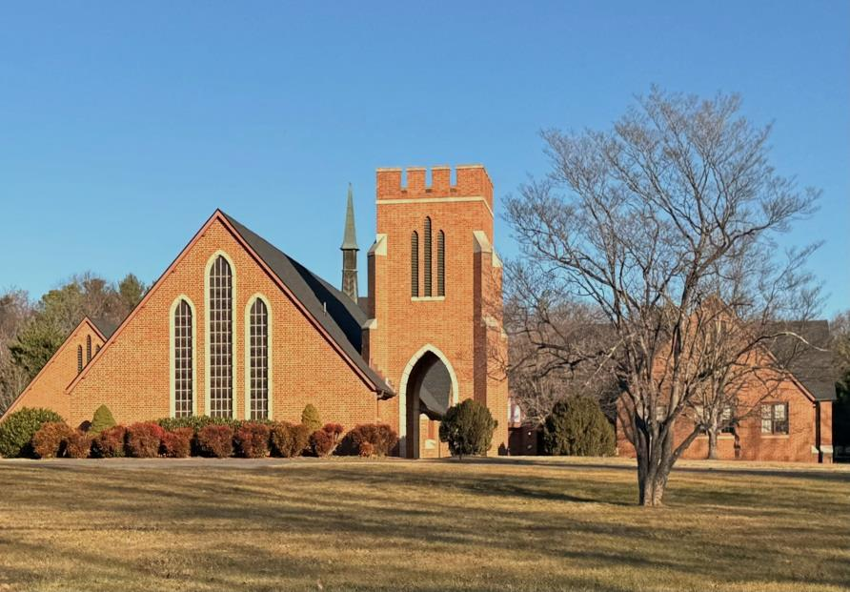
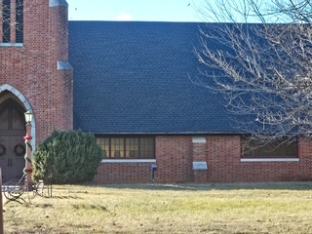
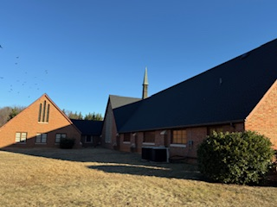

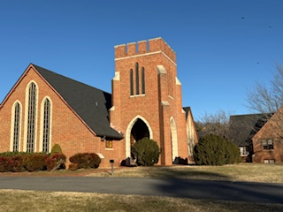

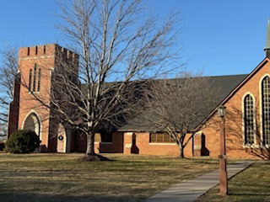

6


We have been so busy this holiday season learning about the true meaning of Christmas, the birth of Jesus Christ. The children have been working so hard practicing for their Christmas Program. They have created Christmas crafts each day to put together a gift bag for their parents to receive. It was so wonderful to watch them perform; Mrs. Laney and I are so proud of each of them. After the program everyone joined for cookies and milk in the Social Hall, and it was a beautiful end of the 2025 school year.
Mrs. Laney and I look forward to the children’s return after Christmas break! It is going to be a fun filled New Year, with new crafts, and new lessons.

Wishing you a season filled with joy, gratitude, and God’s blessings.
St. John’s Preschool Staff
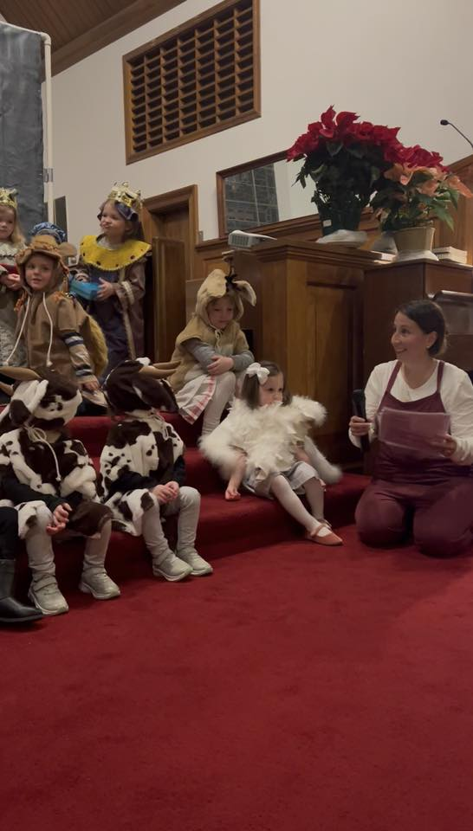
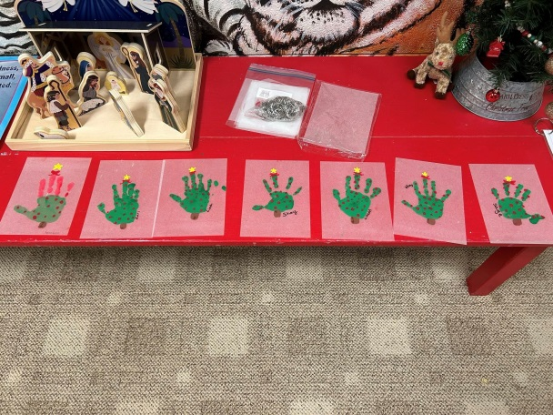

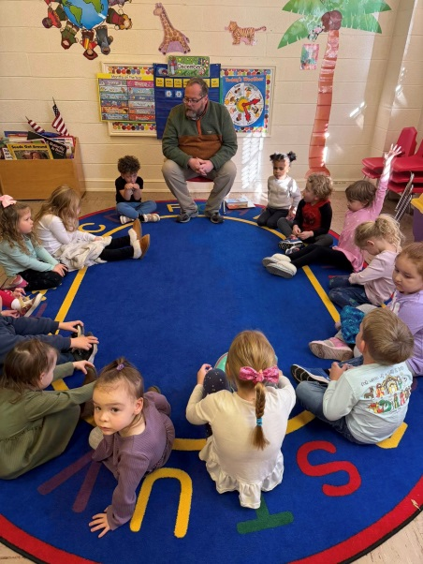

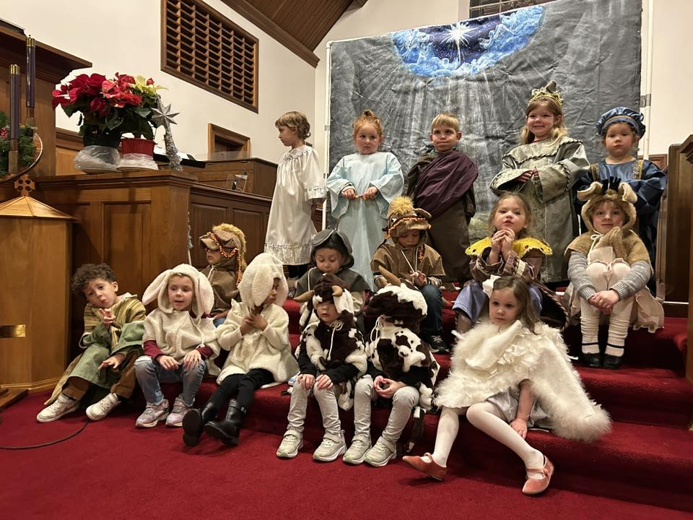

3
Church News


Trustees

We are very happy to say that we have finally been able to replace our 68 year old roof! This process started with the sale of the Jollivue property. The Trustees then got 3 estimates from roofing companies. Holloway Roofing was chosen for several reasons. One of the main reasons we chose them is that they pointed out that we had wind/hail/storm damage to our roof. They took lots of pictures, even bringing their own drone, to document all of the damage. I then filed a claim with our insurance company, Church Mutual, for the damages. They sent an engineer, a building consultant and an insurance company adjuster to inspect it. Justin, from Holloway Roofing was present for all of this and made sure they saw all of the documented damage.
The end result is that the insurance company confirmed that we did have storm damage and therefore they will be covering the cost of the new roof! They should be completed their work by the end of the week (12/19). We will have a new roof at no cost to the Church!

Next, the Trustees will be getting estimates for repairing all of the exterior and interior water damage from having a roof that leaked.

We had a successful clean-up day on Sunday, Nov. 16. We had at least 25 people helping, including most of the youth. We did a lot of trimming, raking leaves, etc. and also got rid of a lot of cobwebs inside. The Courtyard looks great!

Kim Harris, Trustees Chair


Finance Committee

For the month of November:

Deposits- $346,199.27 ($20,000- one time yearly donation:
$319,856.10- check from Church Mutual for roof)
Expenses- $9,611.66

For the month of December (as of 12/21):

Deposits- $6,714.24
Expenses- $12,971.08

Our offerings on Sundays are still not enough to cover monthly expenses. Please continue to keep this in mind as you consider your giving.

Thank you for your consideration,

Kim Harris & Donna Elkins, Finance Committee co-chairs

4


Annual Christmas Bazaar
Once again, we had a very successful Christmas Bazaar on Sat., Dec. 6. We had vendors, silent auction,
indoor yard sale, bake sale and breakfast and lunch was served. We raised a total of just under $5,200.!!

Thanks to all who donated items, worked before and the day of the Bazaar and to those who came and shopped!


Noisy Can Offering - Shade and Fresh Water Project

Bring your change or bills the first Sunday of each
month for the “noisy can offering.” To date the Youth
have collected $874.31.
Thank you for your continued support.



St. John’s will be hosting the WARM shelter from February 9th-16th.. The WARM Shelter is a no barrier shelter for people experiencing homelessness. As the host church, we will be providing breakfast, lunch and dinner for the week. Please contact Cindy Phillips if you are interested in helping with meals. Along with the meals the WARM Shelter asks for One volunteer each night from 6-10 pm and one perhaps the same to stay overnight (The overnight volunteer can sleep). Donation of quarters for laundry and gift cards (small amounts) for prizes are also needed. Help setting up during the day on Monday, February 9th would be appreciated. Please be on the lookout for more information in the upcoming weeks. Thank you in advance for your help!
5

